12th July, 2017

For worldwide power line voltage and frequencies.

<http://www.school-for-champions.com/science/ac_world_volt_freq_list.htm#.WXAMFoiGOMr>

Seems like most of the countries use their outlets on 220V, 50 Hz. But according to the link above, the optimal setting is 220-240V at 60 Hz.

Also learnt that the national grid always carefully maintains the frequency. So there’s less need of measuring the frequency. But this can be added as a feature as it will not affect any computing power or cost.

13th July, 2017

Looking for papers online for circuits that can find me the RMS voltages and Currents. So that we can calculate the power.

There's no easy solution for it. Everywhere I look the circuits look bulky and complicated. Mainly because it uses step down tranformers.

Found a paper on IEEE Explore about measuing power for home appliances. But not sure if it can use the same microcontroller we are using. Experimentation is needed.

Need a solution that can measure the RMS currents and voltages and then output a range of analog signal. Something that is used on Digital Multimeters perhaps.

16th July, 2017

Found a circuit diagram for measuring RMS voltages used in a multimeter.

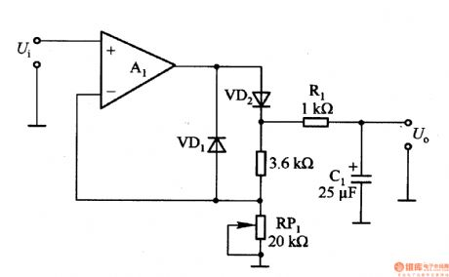

Reference: http://www.seekic.com/circuit_diagram/Basic_Circuit/RMS___DC_converter_circuit_for_measuring_AC_voltage_in_digital_multimeter.html

18th July, 2017

Found a few IC that can measure true RMS voltage, current, Real power and Reactive power. Looks like they are dedicated microprocessors specifically designed for this task.

This is something that we can work with as we can measure any power loss or consumtion for the users.

Such ICs are namely MAXQ314 - But not sure if they are still in production or not. Need further looking in to.

Another IC is AD8436. For PSpice model: http://www.bdtic.com/en/adi/ad8436

The other IC that looks promising is 78M6613 with the same features as the former but may still be in production. Needs more investigation.

Looked for the ICs online on bangladeshi sites but didn't come up with any results. Need to visit stores for any luck.

21st July, 2017

Checking the datasheet for IC 78M6613. IC uses UART communication. Rated at 3.3V for biasing. But still need to know how to connect the rest together with the microcontroller.